Online Resume

Programming Skills

HTML

CSS

JAVASCRIPT

Employment

Per Scholas

Student Support: task includes developing support materials for students. Working with Instructors, Instructor Assistants as well as other support staff to communicate and overcome student concerns and academic barriers and obstacles for learning.

Danielle Scott Name: Danielle Scott

Developer Adress: Columbus, Ohio

Website: NewDev@time2code.com

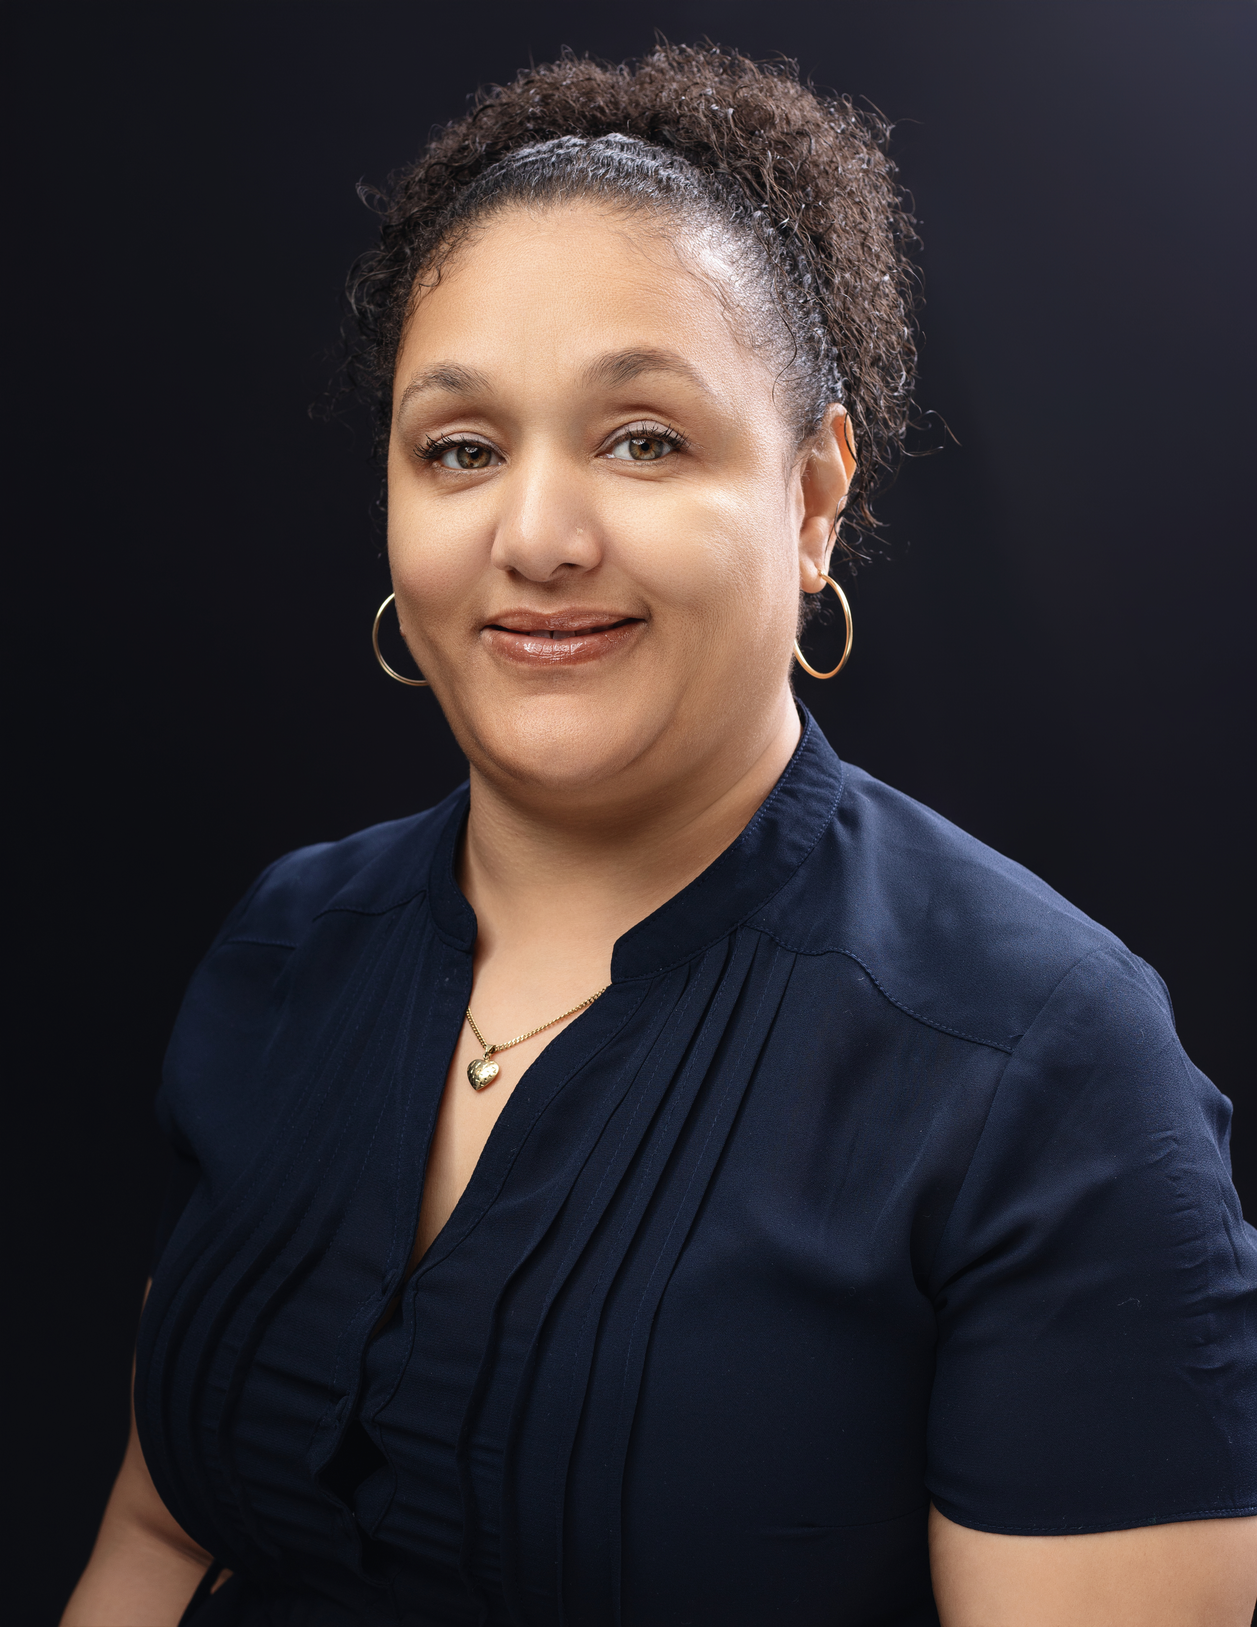l

I am a skilled full-stack developer with experience in front-end and back-end technologies. I specialize in developing end-to-end applications that provide and optimal user experience.

